**Technical Feasibility Review**

**Case 1:**

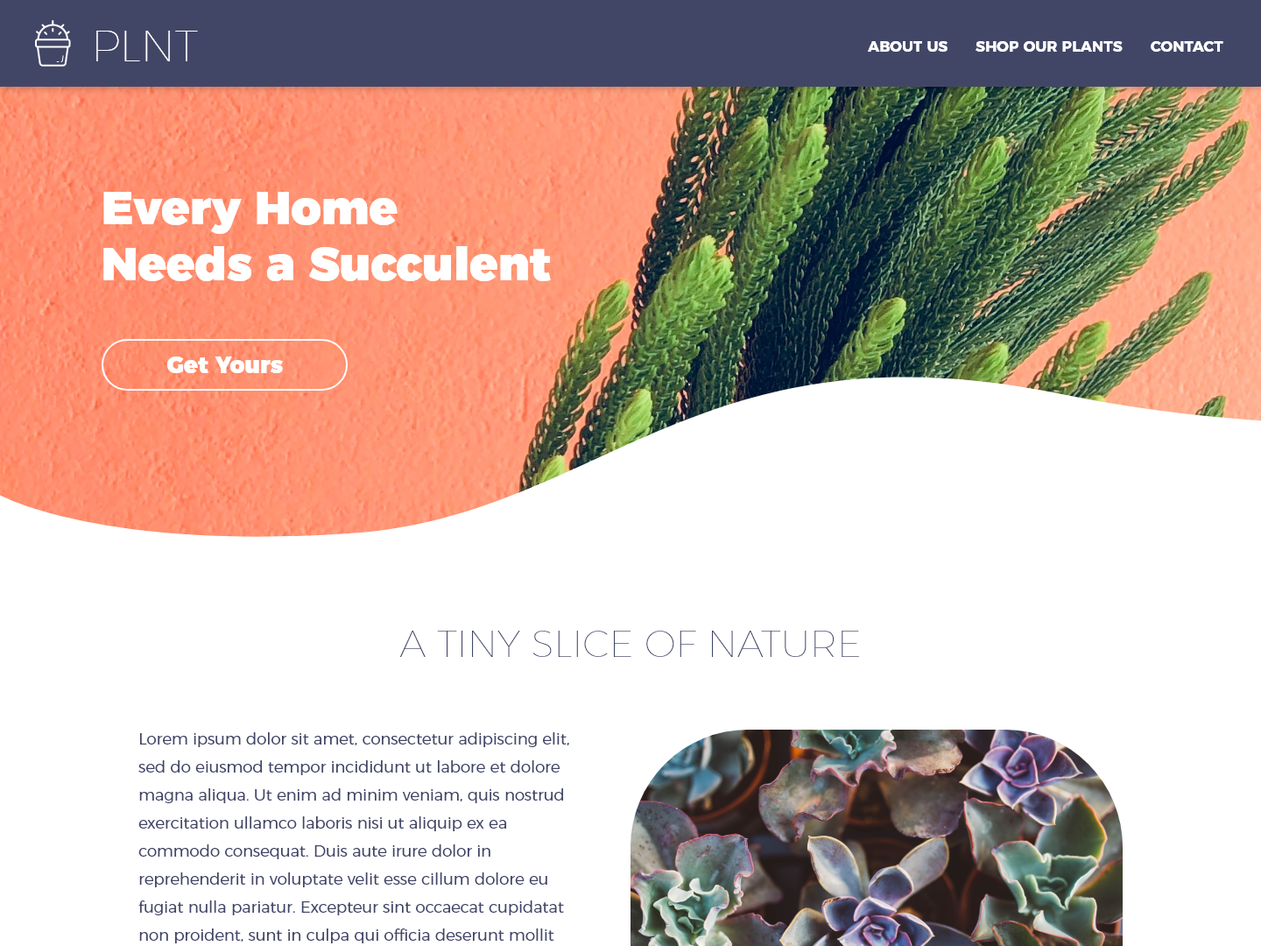

**Feasibility:**

* The curved image at the top can be set as a fixed background using css, not an absurd amount of work to build this design. Although there is a pixilation risk on larger screen resolutions.

**Recommendations:**

* A simpler option might be to use a gradient background using css without it being an image.
* Compared to exporting an image, using an inline SVG is more performant and responsive
* Also, a simple curve may be easier to implement using the “border-radius” property instead of the “S” curve in the design.
* On researching “non-rectangular headers”, I found this [article](https://css-tricks.com/creating-non-rectangular-headers/) (<https://css-tricks.com/creating-non-rectangular-headers/>).

**Case 2:**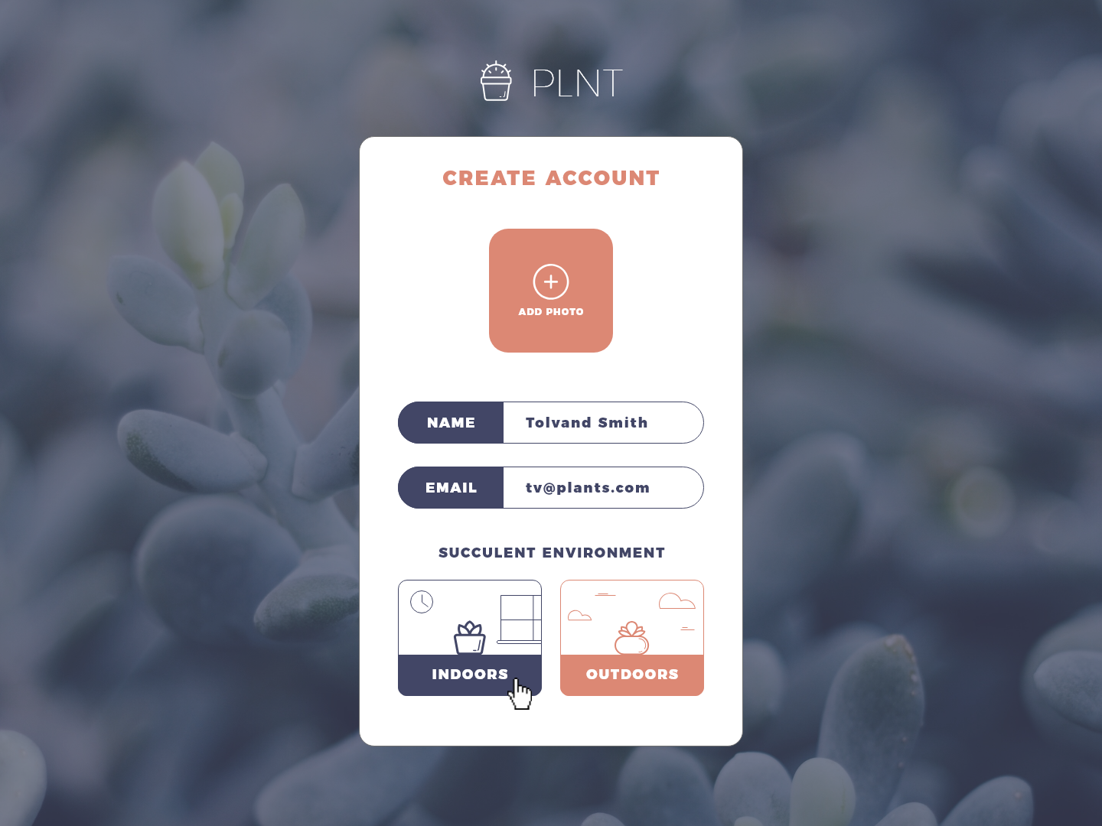

**Feasibility:**

* The design suggests that clicking on “Indoors” and “Outdoors” would submit the form, and that would be confusing to the user. Would push back and request that the designer re-consider this.

**Recommendations:**

* Recommend initially only having a “Sign Up” or “Submit” button to create account and remove the “Indoors” and “Outdoors” options.
* After the user has clicked the commit button, display a message saying the user has successfully created an account, and then display the options to choose the “Indoors” or “Outdoors” option to continue.

**Case 3:**

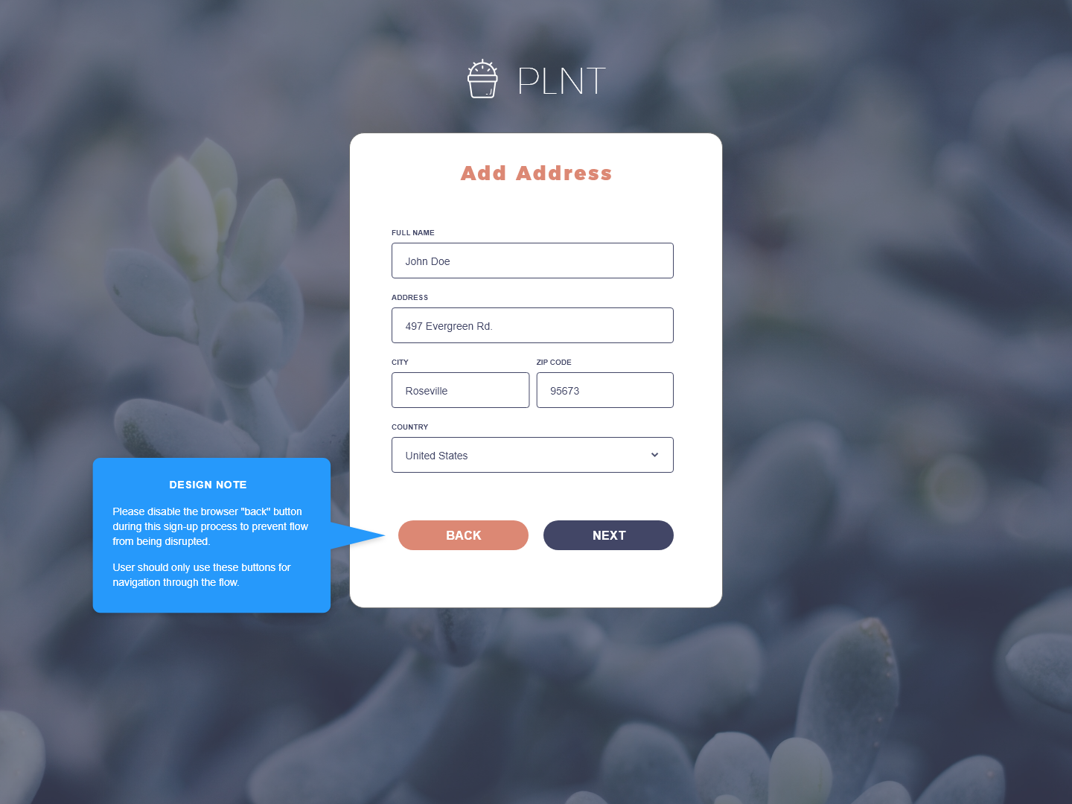

**Feasibility:**

* The browser “Back” button can be disabled with some amount of work using JavaScript.
* Although studies have showed that users have clearly defined expectations of where the Back button should take them and can get easily frustrated if doesn’t work like they expect them to. Found this [article](http://www.usabilitysciences.com/2012/07/back-me-up) (http://www.usabilitysciences.com/2012/07/back-me-up) on the usability aspect of disabling the browser “back” buttons.
* Agree with the designer on the providing an alternate prominent and well labeled navigation - that should allow users to step backward through the process, taking them to their expected result and saving all their data without forcing them to start over from the beginning.